AI-Powered Emotion Detection from Text

Internship Project Report
1. Introduction
Emotion detection is a Natural Language Processing (NLP) task that aims to identify the emotional state expressed in a piece of text. Unlike traditional sentiment analysis, which generally classifies text as positive, negative, or neutral, emotion detection provides a more detailed understanding by categorizing text into specific emotions such as sadness, joy, love, anger, fear, and surprise.
Emotion detection has numerous real-world applications including customer feedback analysis, social media monitoring, conversational AI, recommendation systems, and mental health support systems.
This project focuses on building a machine learning-based emotion detection system capable of predicting emotions from textual input using NLP preprocessing techniques and classification algorithms.

2. Objective
The main objectives of this project are:
- To understand Natural Language Processing workflows.
- To preprocess textual data for machine learning.
- To convert text into numerical representations using TF-IDF.
- To train and compare multiple machine learning models.
- To evaluate model performance using standard metrics.
- To predict emotions from unseen text samples.

3. Dataset Description
The project uses the "dair-ai/emotion" dataset obtained from the Hugging Face dataset repository.
Dataset Information
Dataset Split | Number of Samples
Train | 16,000
Validation | 2,000
Test | 2,000
Emotion Classes
The dataset contains six emotion categories:
Label | Emotion
0 | Sadness
1 | Joy
2 | Love
3 | Anger
4 | Fear
5 | Surprise
Example Dataset Record:
Text:
"I didnt feel humiliated"
Label:
Sadness

4. Exploratory Data Analysis (EDA)
Before training the model, exploratory analysis was performed to understand the dataset characteristics.
Dataset Quality
- Total training samples: 16,000
- Missing values: None
- Data format: Text and corresponding emotion label
Emotion Distribution
The emotion distribution revealed that the dataset is not perfectly balanced.
Emotion Counts:
- Sadness: 4666
- Joy: 5362
- Love: 1304
- Anger: 2159
- Fear: 1937
- Surprise: 572
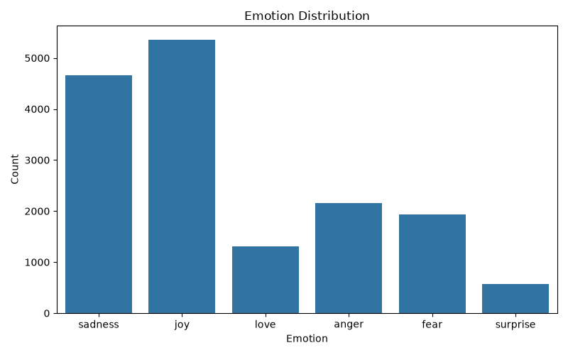
Observation:
The "Joy" class contains significantly more samples than the "Surprise" class. This class imbalance may affect prediction performance for minority classes.
Sentence Length Analysis
Statistical analysis of sentence lengths was performed.
Results:
- Average sentence length: 19.17 words
- Minimum sentence length: 2 words
- Maximum sentence length: 66 words
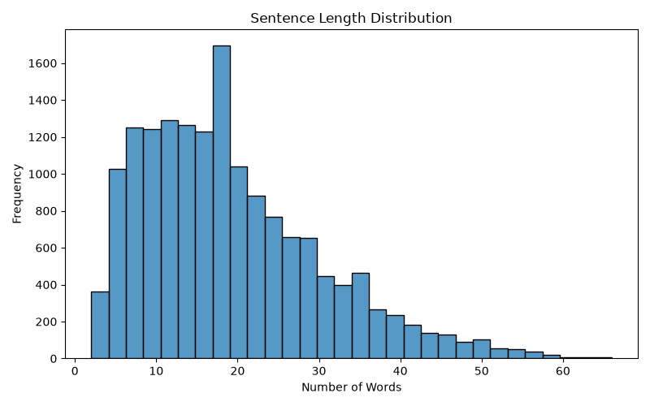
Observation:
Most sentences are relatively short, making TF-IDF a suitable feature extraction technique.

5. Text Preprocessing
Raw text cannot be directly used by machine learning models. Therefore, several preprocessing steps were applied.
Preprocessing Steps
- Lowercasing
- URL Removal
- Special Character Removal
- Tokenization
- Stopword Removal
- Lemmatization
Example:
Original Text:
"I am VERY happy today!!!"
Processed Text:
"happy today"
Special consideration was given to words such as "not", "no", and "never" because they significantly influence emotional meaning.
Example:
Original:
"I am not happy"
Processed:
"not happy"
This preserves the emotional context of the sentence.

6. Feature Extraction Using TF-IDF
Machine learning algorithms require numerical input. Therefore, textual data was converted into numerical feature vectors using TF-IDF (Term Frequency-Inverse Document Frequency).
TF-IDF measures the importance of words within a document relative to the entire dataset.
Advantages of TF-IDF:
- Converts text into numerical features.
- Reduces the impact of extremely common words.
- Highlights important emotion-related terms.
- Works efficiently on short text datasets.
Configuration Used:
- Maximum Features: 10,000
- N-gram Range: (1, 2)

7. Model Training
Two machine learning models were trained and compared.
Model 1: Multinomial Naive Bayes
Naive Bayes is a probabilistic classification algorithm commonly used for text classification tasks.
Advantages:
- Fast training
- Computationally efficient
- Effective baseline model
Model 2: Logistic Regression
Logistic Regression is a supervised machine learning algorithm widely used for classification problems.
Advantages:
- Strong performance on TF-IDF features
- Interpretable results
- Effective for multi-class classification

8. Model Evaluation
The models were evaluated on the validation dataset using Accuracy and F1 Score.
Validation Results
Model | Accuracy | F1 Score
Naive Bayes | 75.15% | 71.16%
Logistic Regression | 88.85% | 88.50%
Observation:
Logistic Regression significantly outperformed Naive Bayes and was selected as the final model.
Final Test Performance
The selected Logistic Regression model was evaluated on the unseen test dataset.
Results:
- Test Accuracy: 88.05%
- Test F1 Score: 87.58%
Classification Report
Emotion | Precision | Recall | F1 Score
Sadness | 0.90 | 0.95 | 0.93
Joy | 0.85 | 0.96 | 0.90
Love | 0.85 | 0.62 | 0.72
Anger | 0.91 | 0.84 | 0.87
Fear | 0.90 | 0.82 | 0.86
Surprise | 0.89 | 0.48 | 0.63
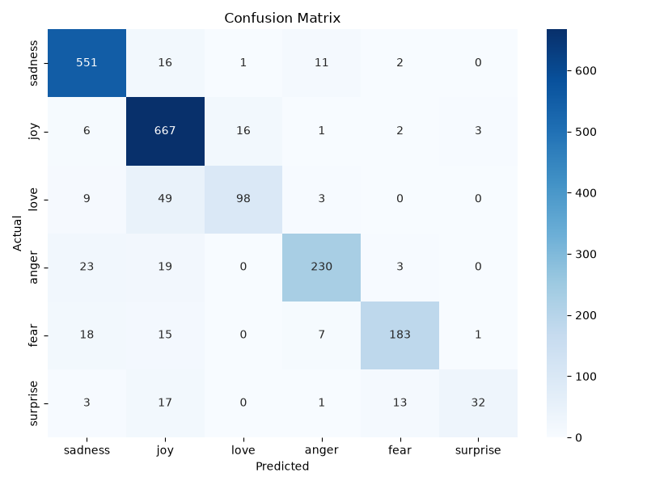
Observation:
The model performed best on Sadness and Joy. Performance on Love and Surprise was lower due to fewer training samples in those categories.

9. Sample Predictions
Example 1
Input:
"I am extremely happy today."
Predicted Emotion:
Joy
Confidence:
68.81%
Example 2
Input:
"I feel lonely and hopeless."
Predicted Emotion:
Sadness
Confidence:
98.18%
Example 3
Input:
"I am terrified of tomorrow."
Predicted Emotion:
Fear
Confidence:
94.23%
Example 4
Input:
"This makes me furious."
Predicted Emotion:
Anger
Confidence:
68.55%

10. Applications
Potential applications of emotion detection include:
- Customer support sentiment analysis
- Social media monitoring
- Mental health support systems
- Chatbots and conversational AI
- Feedback analysis systems
- User experience monitoring

11. Conclusion
This project successfully developed an AI-powered emotion detection system using Natural Language Processing and Machine Learning techniques.
The workflow included dataset analysis, text preprocessing, TF-IDF feature extraction, model training, model comparison, and evaluation. Two machine learning algorithms were tested, and Logistic Regression was selected as the final model due to its superior performance.
The final system achieved an accuracy of 88.05% and an F1 score of 87.58% on unseen test data, demonstrating its effectiveness in detecting emotions from text.
Future improvements may include the use of advanced deep learning models such as LSTM networks and Transformer-based architectures to further improve performance, especially on minority emotion classes.

